Early Mathematics Coherence-PK2
(EMC-PK2)

Dale C. Farran, Ph.D.
Kelley Durkin, Ph.D.
Luke Rainey, M.Ed.

2022-2023

Manual for Early Mathematics Coherence - PreK through 2nd Grade Classroom Observation Instrument
This instrument was adapted from the Classroom Observation of Early Mathematics-Environment and Teaching (COEMET version 4; Sarama & Clements, 2010) (and the Advanced Narrative Record of Early Childhood Classroom Observations (Farran, Meador, Keene, Bilbrey & Vorhaus, 2015) ) and the Post Observation Rating Scale (Farran, Meador & Yun, 2015). The goal is to capture elements of mathematics teaching and learning across the early grades, from Pre-Kindergarten through 2nd Grade. The focus of this measure is on alignment and coherence across classrooms and teaching practices that often appear quite different.
The original version of the instrument was used for the longitudinal COHERE project as part of the Development and Research in Early Math Education (DREME) Network. Based on data analysis from that project, the EMC-PK-2 tool was redesigned, adding new items, reworking items for clarity, and changing the layout to improve usability.
This instrument has been formatted for use on tablets, using the FileMaker Go application.

GENERAL INSTRUCTIONS
Observers spend the full period of math instruction in the classroom, beginning before the lesson begins until after the children transition to the next content area. In Pre-Kindergarten classrooms, the observation period will be a half-day (usually 180 minutes long) and in Kindergarten through 2nd grade classrooms the observation period will be approximately 60-90 minutes long.
Note-taking is a critical part of using this observation tool, and you will see several places to record notes. Use the notes fields to record both general and specific information about what you see, hear, and notice in the classroom. These notes support the ratings; without notes to justify the ratings, there is no way to validate them. The notes also allow comparisons across observers to make sure that similar behaviors are being rated similarly.
The instrument is divided into 3 sections: Cover Page, Intentional Math Activities (IMAs), and POST. Observers complete the Cover and POST sections once to reflect the entire observation.

Observation Day
- Open FileMaker using username and password
- Start on the Cover Page
- Search by Visit ID Number on your roster (provided by your site coordinator)
- Select or enter your name as the Observer
- Enter the date of the observation
- Double-check that the Grade Level is correct
- Select Yes/No for Teacher Assistant present.
- Count and enter the number of children, parents/volunteers, and other staff (not teacher or assistant)
- Enter observation start time
- Complete Intentional Math Activity (IMA) for each math activity
- When observation ends, enter End Time on Cover page.
- Complete the POST section
- Check the languages heard during instruction the Cover page.
- Add any additional notes and/or questions about the observation in the Notes box on the Cover page.
- Review your data in depth using the data checker checklist. Add notes and update ratings as needed.
- Make sure you’re connected to WiFi and press the Send Data button. Check your Outbox to make sure the email sent correctly.
- External data checkers should review the observation record for accuracy, finding corroboration for ratings within the notes.

COVER PAGE
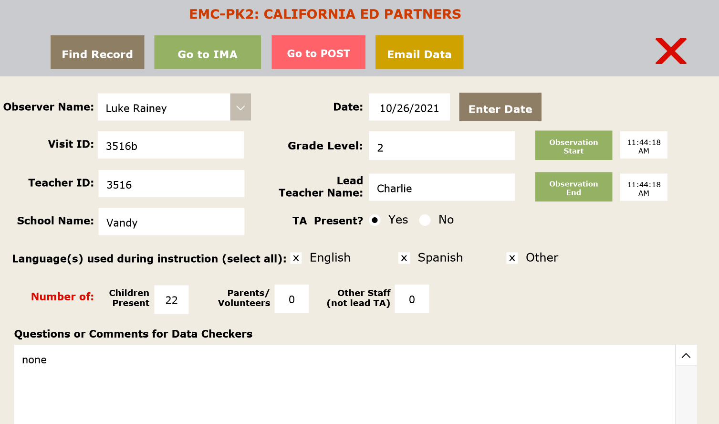

Much of the Cover page can be filled out before the observation begins. It is mostly demographic information and includes a notes field for the observer to include any questions or comments about the data.
Observer Name: Pre-populated, select your name from list
Visit ID: Pre-populated based on what teacher was selected on Opening Screen. Teacher ID, with a letter that denotes what observation it is
Teacher ID: Pre-populated based on what teacher was selected on Opening Screen.
School Name, Lead Teacher Name and Grade Level should be automatically populated based on the roster information provided. If the information is inaccurate, the observer should explain in the Notes field.
Date: Tap the Enter Date button and today’s date will populate.
Teaching Assistant Present: If there is one (or more) assistant present in the classroom during the observation, mark yes. If there are multiple assistants, add a description or explanation to the Notes field and include the count of all TAs minus the lead TA in the number of Other Staff.
Language(s) used during instruction (select all): Mark the languages used during instruction. Do not include social interactions. Mark the English and Spanish checkbox if applicable, and Other if another language is spoken. Write what language it was in the Notes section.
Number of Students Present: This should be the greatest number of children that are present in the class during the observation period. This information is also used to calculate the 75% marker used to determine “most of the class.”
Number of Parents/Volunteers: If parents or volunteers stay in the class beyond drop-off or a brief conversation, count them in this total. Enter 0 if no parents or volunteers are present.
Number of Other Staff: If any school or district staff, outside of teachers and assistants assigned to the classroom, are in the classroom during the observation, count them in the total. Do not include individuals who stop by for a brief conversation. Enter 0 if no additional staff are present.
Observation Start Time: Enter the time at the beginning of the classroom observation, NOT the beginning of the first math activity. There will separate start time fields for each math activity as well.
Observation End Time: When you have completed your observation, enter the end time here.
Notes: Add any overall notes about the observation. This is also a good place to leave notes for the data checking team about any questions you might have about data or items you think they should pay attention to.

INTENTIONAL MATH ACTIVITY (IMA)
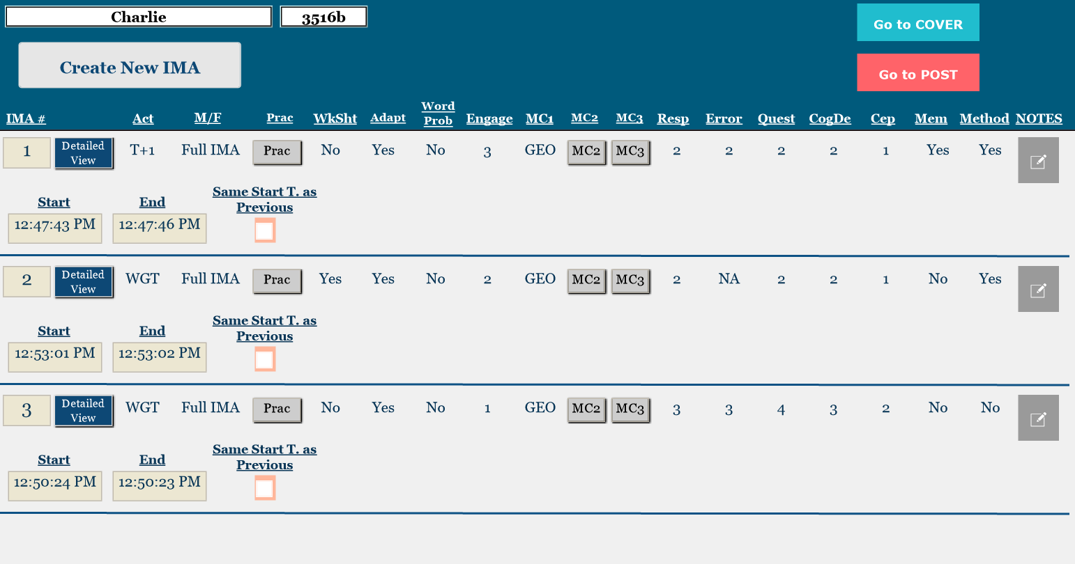
Observers complete a separate Intentional Math Activity (IMA) row for each observed math activity defined as a substantive activity. That is, the activity must be set up and/or conducted intentionally by the teacher involving several interactions with one or more children or set up or conducted intentionally to develop mathematics knowledge (this would not include, for instance, a single, informal comment). The math activity must persist for more than one minute. Observers complete the IMA ratings once for each unique intentional math activity. If there is no math activity going on, then there will be nothing for observers to code or note until an IMA begins. For this study, we are just focused on classroom practices during math instruction.
There are two types of IMAs. Observers must decide which type they are observing and fill out the correct IMA type, either a “Full IMA” or a "Mini IMA." Mini IMAs are those math activities which last for at least a minute, but in which neither teachers nor assistants are involved for a minute or more in the math. Center activities are often Mini IMAs, as well as student-led daily calendar activities, routines, and songs. Full IMAs are more extended activities, in which the teacher is involved in the math for one minute or more, regardless of the number of children involved.
If neither the teacher nor assistant is engaged in a math activity, but children are engaged in an activity an adult intentionally set up, this would be a Mini IMA. Similarly, if the mathematics activity was directed by an adult, but involved no substantial introducing or focusing interactions, this would be a Mini IMA. Independent centers/stations/groups are also coded as Mini IMAs unless the teacher is involved in that station in mathematics instruction for more than one consecutive minute. For more information about rating Mini or Full, see p. 14. For more information about Full IMA ratings, see pp. 23-29.
For both Mini and Full IMAs, there can be only one Activity Type setting, or grouping of teachers and/or students. If the activity setting changes, then that portion of the activity becomes a separate IMA. For example, if students are working individually on a worksheet for over a minute, and then the teacher has the whole class share answers and solution strategies, you would have one IMA for when students worked individually and start a new IMA for the whole class portion of the activity. More about Activity Type codes on pp. 11-14.
The first time you Go to IMA, you will automatically have IMA #1 to work on. For a new IMA, press Create New IMA button. IMAs will be numbered in order, regardless of whether they are Mini or Full IMAs.

How do I know how many IMAs there are?
You should ALWAYS create a new IMA when:
- there is more than one minute of non-math content between activities
- the activity setting changes for more than one minute
- the teacher accommodates a small group to work on a particular focus that is different from other groups (e.g., a word problem is changed to focus on counting and cardinality skills for a small group)
You should NOT create a new IMA if:
- the teacher walks students through the task, or asks them questions
- the teacher provides adaptations (e.g., offers some students new tools, new strategies, or new connections)
- there is a small group of students working with a TA on the same activity/objective as the rest of the class
If you’re unsure, it is ALWAYS better to err on the side of making more IMAs than necessary. It is much easier for the data team to merge IMAs than it is to break them apart.
Here are some examples:
[Whole Group Teacher] – [Independent] – [Whole Group Teacher]
This activity flow would be 3 IMAs, regardless of how much time elapses between setting changes. This is because the activity type changes.
[Whole Group Teacher] – [Transition, more than one minute] – [Whole Group Teacher]
Even though the activity type doesn’t change, this would be 2 IMAs because there is more than one minute of non-math activity between the two activities.
[Whole Group Teacher] – [Transition, less than one minute] – [Whole Group Teacher]
This is only 1 IMA because there is less than one minute of non-math activity between activities. You would just write a few words about the transition that happened and continue on in your notes.
[Whole Group Teacher] – Breakout: [Students are working in Pairs with teacher and TA circulating, all students working on same activity]
Even though the teacher and the TA may have different kinds of interactions with the students, this would be 2 IMAs because the all the students are working on the same activity in the breakout session. If either the teacher or the TA engage in more than 1 minute of math instruction or talk with students, this would be a full IMA. As noted before, you would start a new IMA for the breakout session regardless of how much transition time after the Whole Group Teacher IMA because of the activity setting change.
[Whole Group Teacher] – Breakout: [Students are working in Pairs with the Teacher circulating to support them] and [TA has pulled a small group of students to work on different math content]
This is 3 IMAs, because the teacher and TA are doing significantly different activities during the breakout session. As noted before, you would start new IMAs for the breakout session regardless of how much transition time after the Whole Group Teacher IMA because of the activity setting change.
[Whole Group Teacher] – Breakout: [Most of the students are working in pairs] while [TA is working with a small group on different math content] and [Teacher is working with a small group on different math content that is different from the TA’s activity or the pair activity]
In this case, you would have 4 IMAs because the group with the teacher, the group with the TA, and the students working in pairs are all doing substantially different activities. As noted before, you would start new IMAs for the breakout session regardless of how much transition time after the Whole Group Teacher IMA because of the activity setting change.
But what happens when…
…there is a behavior incident that interrupts instruction for more than 1 minute?
You should start a new IMA, as there is over one minute of a non-math activity (behavior management). We would think of it as a non-math “transition.” In the moment, it can be hard to gauge how long a behavior incident will last, so you could also make a note of the time that the incident starts and stops, and if it’s more than a minute, the data team can split that IMA for you.
…there is a super quick math activity that lasts less than one minute, then a transition that lasts over a minute, and then a new math activity starts?
If you started writing notes for the super quick math activity, you can keep them and continue with notes for the full-length IMA. Just remember to hit the “Start Time” button again, when the full-length IMA starts.
Note about Concurrent IMAs
Observing multiple IMAs concurrently can be difficult. Of course, one observer cannot be everywhere at once. Prioritize in the following way:
- Create rows for all of the different IMAs. Make a little note for each of them so you can differentiate them. (e.g., Teacher station/puzzle activity). Press the “Same start time as previous” box to copy over the same start time from the preceding IMA.

- Start with the activities being led by adults/likely Full IMAs. Spend enough time to capture a general sense of what the activity is and how the teacher is interacting with students (how are they responding, asking questions, etc.). If this is an in-depth discussion, you may want to stay longer to make sure you capture the range of practices.
- Then circulate to each of the student-only IMAs (Minis) and write some brief notes about the activity structure, what math they’re working on.
- Make your way back to the Full IMA(s) and take more notes.
- Do your best!

Starting a new IMA
Enter the Start Time and the End Time for each IMA by pressing the related buttons.
If two activities start concurrently, mark the Same Start Time box (pictured below). Selecting this option will enter the start time of the previous IMA. This may be common during centers with multiple simultaneous activities that start at the same time. This is a way for the observer to save time and be more accurate when creating many new IMAs at once.
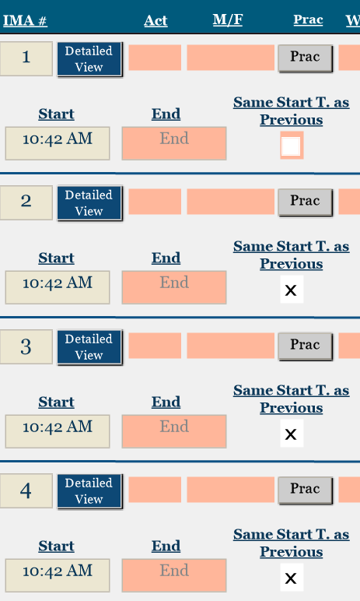

IMA Notes
In the IMA Notes, the observer should provide as detailed information as possible about the math that was happening and the instructional interactions during the activity. This should serve as a basis for the IMA ratings, and should explicitly clarify the ratings for anyone who was not present during the observation.
- What the teacher is doing and/or saying
- What the children are doing and/or saying
- Information about math objectives mentioned or discussed
- What the teacher does to assess children’s knowledge or understanding (formally or informally)
- Any other information that can assist you in making accurate and reliable ratings as well as assist the person checking your data
- Questions you have about how something should be coded
The ratings require explicit evidence from the notes. Observers should balance recording notes with explicit teacher and student dialogue and action with general, summative statements. If you need to hold off on filling in IMA ratings or checkboxes until after the observation, then DO THAT! In the moment, focus on taking explicit notes. Then you can draw from them later and fill in missing items.
The notes can be accessed from both the row view:
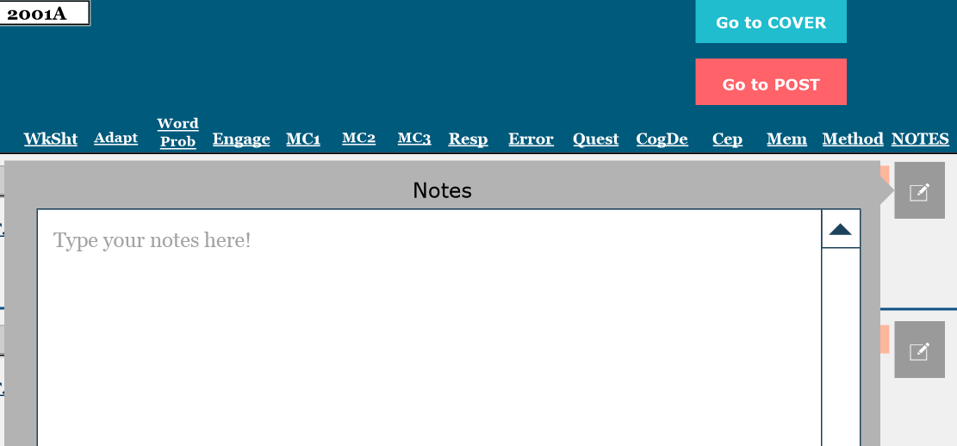
And from the Detailed View:
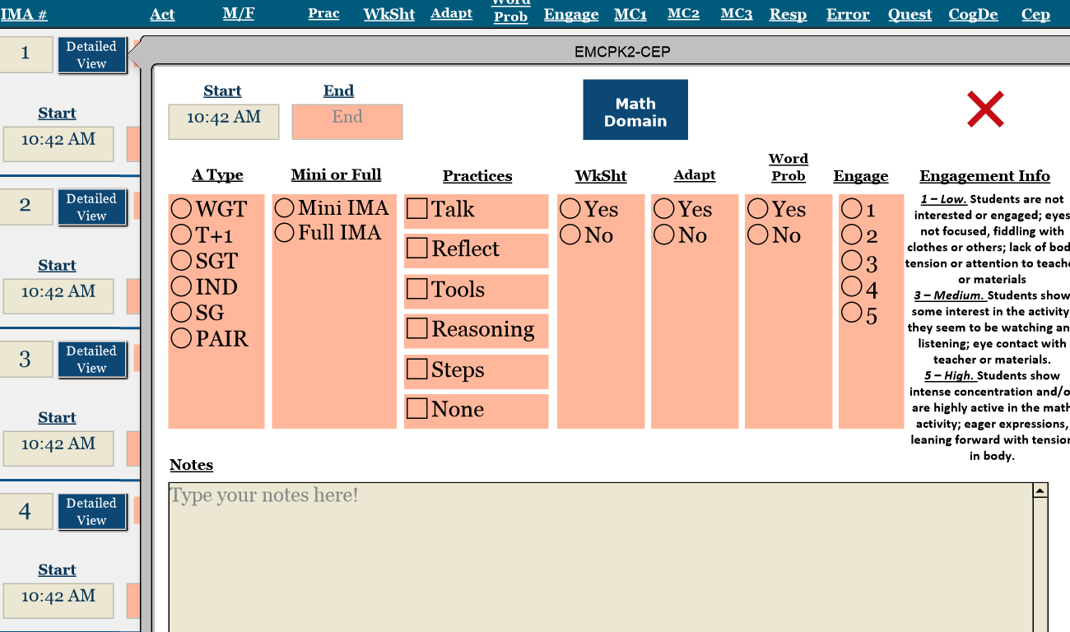

IMA Codes
IMA codes can be selected from either the Row View or the Detailed View. The Detailed View is recommended for most ratings as it provides more information about the codes. The row view can be helpful for making quick changes or for reviewing data to inform Post coding.
Activity Type describes the setting of the IMA. Mark the Activity Type the teacher intended, regardless of how engaged the students are. For instance, if the teacher says to get in pairs and only a few students are successfully working in pairs, still code Pairs.
- Whole Group Teacher: Most of the class (75%+) is working with the teacher
- Teacher and 1 Student: Teacher is working with a single student on a unique activity. Note: a teacher may circulate to work with individual students during a variety of activity types. This code refers to activities where no other student in the class is working on this math activity objective. Example: a teacher comes over to a child at recess and prompts him to name the relative position of other students on the playground. This is most likely to occur during Pre-K.
- Small Group Teacher: A small group of students (2+) is working with teacher
- Independent: Students are working independently (teacher may be circulating)
- Small Group: A small group of students (3+) is working together without a teacher
- Pair: Students are working together in pairs (teacher may be circulating)

Activity Types
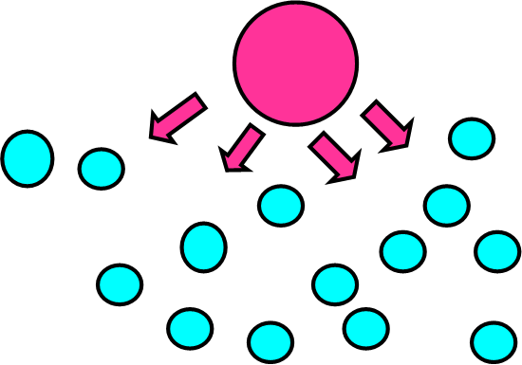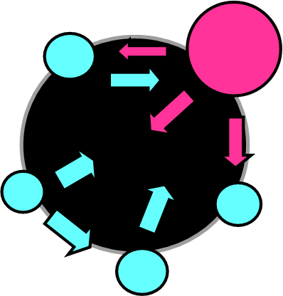
Small Group with Teacher
Whole Group with Teacher

Most of the class (75%+) is working with the teacher A small group of students (2+) is working with teacher

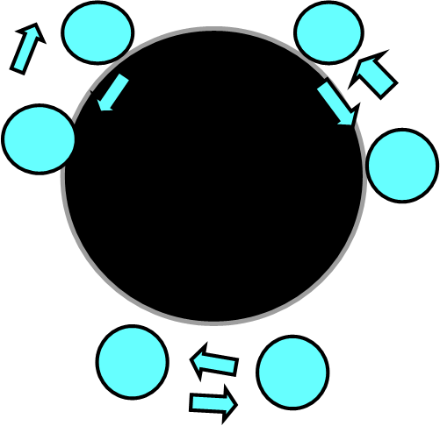
Pair
Small Group

A small group of students (3+) is working together without a teacher Students are working together in pairs

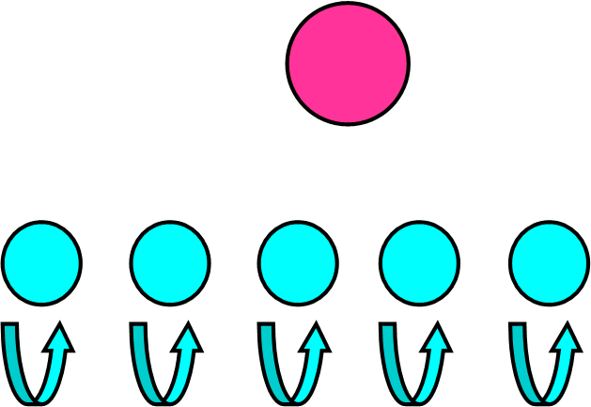
Independent
Teacher and 1 Student

Teacher is working with a single student Students are working independently (teacher may be circulating)

Mini/Full refers to whether the teacher is significantly involved in math instruction during the IMA. Code Mini if there is less than 1 minute of the teacher involved in math instruction. Code Full if there is a minute or more of consecutive involvement in math instruction.
Full IMAs will receive additional ratings focused on the teacher facilitation.

Student Practices are a checklist of math strategies, adapted from the Common Core State Standards, that students may engage in during an activity. Check all student practices that apply in each IMA. This is a specific occurrence and requires accompanying notes.
- Students talk to each other about math: Direct student-student math talk. Conversations in groups or in pairs or even in independent math activities. Do not include sharing an answer with the whole group in response to a teacher’s question unless it is conversational.
- Students use tools or visuals other than paper/pencil: Math tools or manipulatives other than paper/pencil. Examples include number lines, counting bears or other counters, base 10 blocks, abacus, pattern or attribute blocks, geoboards, ten frames, connecting cubes, or students’ own body parts. Students must be directly using or interacting with the tool. Passively watching the teacher model or use the tool would not count. Passively watching a video would also not count.
- Students explain their reasoning: Students verbally explain why they think something or did or would do something a certain way. May be prompted or unprompted.
- Students describe steps they used to solve a problem: Verbal, prompted or unprompted describing of steps students used to solve a problem. Students explain how they did or would solve a problem or describe a strategy they chose. This can be general approach or specific procedure, it does not necessarily need to be sequential (first this, then that).
- None: If you do not observe any of these math practices, mark None.
Is this IMA mainly a worksheet? Yes/No. A worksheet is defined as paper with multiple problems or exercises where students are asked to answer but not to explain their thinking. If students are using math tools/visuals, it is not mainly a worksheet. IMAs that are mainly a worksheet are often Mini Independent IMAs, but not always.
Note: A worksheet doesn’t have to be a print-out. A teacher who has students using markers and parchment paper could count as a worksheet, if the students are just filling in answers, but not showing their thinking or using tools/visuals. For example: A teacher has parchment paper with a small group of students where they draw blanks with a marker, and students are supposed to correctly fill in the numerals that fit in the hundreds, tens, and ones places.
Does the teacher adapt the activity for individual students (at least once)? Yes/No. Adapting an activity involves the teacher making an individualized modification to the activity to help a student better understand the math concept or to challenge them more. Adapting the activity does not mean giving the child an entirely new activity. These are in-the-moment changes to the task that the teacher makes because they see some students already understand or are having too difficult a time.
Examples:
- A Kindergarten student is attempting to count the total number of items in a collection but is having trouble keeping track of the count. The teacher brings over some ten frames, so that the student can place one item in each square and make it easier to keep track of.
- A Pre-K center has students comparing the weights of objects compared to a pile of blocks using a balance scale and sorting objects into different categories based on weight. The teacher sees the students are completing this quickly, so he asks the students to compare how many items were in the heavier and lighter groups to find out which pile is greater.
- A class of first graders is having trouble picking out relevant information from a word problem. The teacher notices this as she walks around while students are solving independently, so she decides to pull the class back together. She takes time to have a conversation with the class about who the problem is about, what they are doing, and in which order. She takes up thinking from students to help clarify. When they return to continue working on the problem, the teacher has them model using Unifix cubes.
Does this IMA involve math word problems? Yes-Basic/Yes-Open/No. For each IMA, code whether it was a word problem, and if so, whether it was presented in a basic or open-ended way.
A word problem needs to have a story element, and the story needs to involve a mathematically relevant type of action.
So if a teacher shows pictures of camels with different humps and says, "we are going to write an addition sentence with one and two hump camels," there is no story and no action within the story. So that would not qualify as a word problem. But if the teacher showed the picture of camels and says, "there were once a bunch of camels in the desert and all the one-humped camels gathered on a sand dune and all the two-humped camels gathered at the oasis. Write an addition sentence to show how many camels there were in all." Then that would count as a word problem: there was a story and there was action within that story (groups of like camels gathering).
Yes – Basic:
Basic word problems are math problems that are removed from immediate context and are usually written. They can be included in any domain of math but appear most often in the Operations and Algebraic Thinking content domain. Many teachers present these in basic ways that just involve students identifying the numbers or operation and then solving in a prescribed way.
Yes – Open:
Teachers may choose to unpack the word problem (math story) together by reading the story together, and then asking what the story is about. The goal here is to make sense of the story situation by eliciting details about and elaborating on the story. The focus is not to identify the numbers or the operation. The teacher may pose an estimation question to see if the students have a sense of what’s happening mathematically in the story. When it’s time to solve, children may solve in any way that makes sense to them.
If the teacher employs a word problem where the focus is simply identifying the numbers or the operation, or students must solve in one way, select “Yes - Basic.”

Student Engagement
The engagement level of the group of students involved in this IMA is:
1 | 2 | 3 | 4 | 5
Low  Students are not interested or engaged; eyes not focused, fiddling with clothes or others; lack of body tension or attention to teacher or materials. |  | Medium  Students show some interest in the activity, they seem to be watching and listening; eye contact with teacher or materials. |  | High  Students show intense concentration and/or are highly active in the math activity; eager expressions, leaning forward with tension in body.

Example:
The teacher is reading the class a math-related picture book.
Anchor 1: None of the students are attending to what the teacher says. While she reads, they pick at the carpet, fiddle with their clothes, or slump listlessly to one side.
Anchor 3: Generally, the students are looking at the book as she reads, but they seem to be doing it because that’s what is expected of them, not because they especially want to hear the story. When the teacher stops to ask the students questions about the book, she mostly has to call on students to answer.
Anchor 5: The students are really excited about this book. They all keep scooting forward to get a better look at the pictures, and whenever the teacher pauses to ask a question, all the students energetically wave their hands in the air or loudly call out the answer.

Math Content

These codes describe the focal content standards of the activity. They were adapted from the Common Core standards for Math in Kindergarten-Grade 2 and the California Pre-K Foundations.

Content decisions are made using a decision tree format. There are three steps to choosing content, and only one option can be coded per step. Pick the main domain, subdomain and content occurring in each IMA:

First: Choose domain (MC1)

Second: Choose subdomain, based on the domain chosen (MC2)

Third: Choose content, based on the subdomain chosen (MC3)
MC1 codes are:
- Content and Cardinality
- Operations and Algebraic Thinking
- Measurement and Data
- Geometry
Some MC3 items use different intervals for counting and adding. Choose item that includes the highest number referenced. For instance:
- Sequential Counting: 1-20
- Sequential Counting 21-100
If multiple MC3 codes apply within one IMA, choose the one that was covered for the most time.
The MC3 content codes within each subdomain are generally ordered in ascending order by corresponding grade level.
See table below for the subdomains and content codes under each domain.
Domain (MC1) | Subdomain (MC2) | Content (MC3) | MC3 Coding Notes
Counting and Cardinality | Compare | Compare: > = < groups of objects | Greater than less than equals, sets of objects or numerals. The “groups of objects” code usually applies to activities where they are not yet representing with symbols, just using comparative language.
 |  | Compare: Numerals 1-10
 |  | Compare: > = < Numerals greater than 10
 | Count Objects | Counting Objects | Sequential counting of objects or focus on 1-1 correspondence.
 | Numeral | Decode/Symbolize Numeral: 1-5 | Decoding or symbolizing number. Not focused on sequence. Numeral is decontextualized (e.g. mixed order or single number). Pick the highest range only.
 |  | Decode/Symbolize Numeral: 6-20
 |  | Decode/Symbolize Numeral: 21-1000
 | Sequential Counting | Sequential Counting: 1-20 | Sequential counting only, no objects. Focus is on naming numbers in order. Often observed counting on the calendar or counting on a number line.
 |  | Sequential Counting: 21-100
 | Skip Counting | Skip Counting by 2's, 5's or 10's under 100 | Focus on sequence more than adding/subtracting. Pick the highest range only.
 |  | Skip Counting above 100
 | Subitize | Subitize | Recognizing a quantity, or set of objects or dots, without counting. Response should be very quick. If students are expected to count in their heads, code under Count Objects.
Geometry | Compose shapes with shapes | Compose specific larger 2D geometric shapes using simple shapes. | For example, “Can you join these two triangles with full sides touching to make a rectangle?” Must be focused on specific shapes not just making designs.
 |  | Compose specific larger 3D shapes using simple shapes. | Same as above except 3D. A common activity is using marshmallows and toothpicks. Must be focused on making specific shapes not just building with blocks.
 | ID Shapes - Basic | Recognizing and Naming Shapes | Identifying typical shapes by name
 |  | Analyze and compare 2D or 3D shapes | Talking about basic defining features of shapes, e.g., number of sides – either one shape at a time or in comparison with other shapes
 |  | ID Shapes: 2D-flat vs. 3D-solid | Is it 2D or 3D? Square vs cube, circle vs sphere for example. Early grades sometimes talk about “fat” or “flat”
 | ID Shapes - Advanced | Defining and nondefining attributes | What makes a shape? For example, triangles are closed and three sided, and it doesn't matter what color or how big they are.
 |  | Draw shapes with specified attributes | E.g., draw a shape with 5 vertices
 |  | Advanced attributes like angles or faces | More advanced version of “Analyze and compare” code. Shape attributes like angles, vertices, or faces. This code is heavily reliant on using the more advanced vocabulary (e.g. angles, faces, vertices) to discuss more precise geometric attributes
 | Model with Shapes | Model shapes in the real world or manipulate shapes to make designs | Model shapes in the real world. A PK standard. Not creating new shapes but manipulating shapes to make pictures, designs, things in the world, or manipulating objects in the world to make shapes. Manipulating Hexitiles, Magna-tiles, math specific shape manipulatives. Finished product approximates a real-world shape, not a specific geometric shape. Does not require identification of the shapes being used or manipulated.
 | Partition shapes into equal parts | Partition circles and rectangles into two or four equal shares | Specifically focused on these math practices. If the focus is on representing as fractions or division, choose one of those standards
 |  | Partition rectangle in rows and columns or circles and rectangles into three equal shares
 | Spatial Reasoning | Identify positions in space | In/ on/ under/ up/ down/ inside/ outside/ beside/ between/ inside/ outside - does not include discussion of lines like "horizontal" "vertical" "diagonal"
Measurement and Data | Attributes | Familiarize attributes | Attributes on a single object. What are the attributes of an object? Like length, weight, size, etc. Does not include geometric shape attributes. Or compare two objects with measurable attribute in common. For instance, two children - one is shorter one is taller.
 |  | Classify and sort attributes | Classify and sort attribute and count category. Must physically sort, not just count one category without separating.
 | Add/Subtract Length | Add and subtract using lengths | Standard measurement only
 | Data/Graphing | Organize, represent and interpret data up to three categories | Categories simple columns. Must also compare the quantities represented to see which is more and less.
 |  | Interpret and solve using graph | Drawing a picture graph or a bar graph (with single-unit scale) to represent a data set with up to four categories. Solve simple put-together, take-apart, and compare problems using information.
 | Measuring | Measure length with nonstandard object | Measuring using blocks, manipulatives, string, body parts, etc.
 |  | Measure length with standard units | Measure length using standard units with a tool like ruler, tape measure, yardstick. Also use this code for when students measure weight of objects.
 | Time | Time: Hours and half hours | Tell and write time in hours and half-hours using analog or digital clocks
 |  | Time: Nearest 5 minutes | Tell and write time to the nearest 5 minutes using analog or digital clocks
Operations and Algebraic Thinking | Add/Subtract | Represent addition/subtraction without numerals | Illustrating an addition or subtraction problem with objects (adding one counter to three counters to make four, having five snacks and eating two, etc.). Also note that if they use objects but then use an equation to represent addition and subtraction, use one of the codes below.
 |  | Add/Sub 0-5 | More formal addition or subtraction using number sentences. Usually written representations but not necessarily as long as they are focused on naming the number sentence. This is 5 and under.
 |  | Find the addend that makes 10 in an equation | Specifically focused on making 10. E.g., what number and 6 make 10?
 |  | Add/Sub: 6-20 | More formal addition or subtraction using number sentences. Usually written representations but not necessarily as long as they are focused on naming the number sentence. This is 20 and under.
 |  | Add/Sub Equations: Unknown addend, missing number, true/false | Finding the unknown addend or missing number for any equation besides making 10 (what number and 7 make 11, 9 and what number make 17?). Also determining if equations are true or false, commutative, or associative properties. The range of numbers for this code are within 100, if the highest number in these types of equations is below or above these numbers, choose Add/Sub >100
 |  | Add/Sub 21-100 | More formal addition or subtraction using number sentences. Usually written representations but not necessarily as long as they are focused on naming the number sentence. Pick the highest range.
 |  | Add/Sub > 100
 | Compose/Decompose | Compose/decompose numbers 100-999 into hundreds, tens and ones | Does not use addition/ subtraction/ equals. Talk of parts and wholes. This should include multiple representations to show that there are different ways to make the number, not standalone problems. Composing numbers is determining which smaller numbers make up a larger number (1 and 3 make 4, 2 tens and 3 ones make 23), while decomposing numbers is determining what smaller numbers a larger number can be broken down into (7 can be broken down into 3 and 4, 71 can be broken down into 7 tens and 1 one)
 |  | Compose/decompose numbers 1-10 (parts-whole)
 |  | Compose/decompose numbers 11-19 into tens and ones
 |  | Compose/decompose numbers 20-99 into tens and ones
 | Fractions | Fractions | Does not include partitioning shapes into equal parts unless there is formal representation as fractions with numerator and denominator
 | Multiplication and Division | Find the sum of objects arranged in rectangular arrays of up to 5 rows and 5 columns | Use addition to find the total number of objects arranged in rectangular arrays with up to 5 rows and up to 5 columns; write an equation to express the total as a sum of equal addends.
 |  | Multiplication and Division | Formal use of multiply and divide terms or representations.
 | Patterns | Patterns - Simple or complex | Extending, replicating and creating a pattern. Focus on a pattern core e.g., ABAB, AABB. This does not refer to activities creating attractive “designs”; it also does not refer to mathematical patterns in general, e.g., finding numerical patterns within a 100s chart.
 | Rounding Base 10 | Round to nearest 10 or 100 | Rounding any numbers to 10 or 100 (9 can be rounded to 10, 82 can be rounded to 80, 198 can be rounded 200, etc.)

Full IMA Ratings
Each Full IMA has a Ratings section of 7 items about teacher and student involvement in the math activity along a 1-5 or binary scale. The 1-5 scales are tied to 3 specific anchors that describe the rating. If the observed practice is an even combination of two anchors, observers should pick the rating that falls in between.
When rating, the observer should start with the anchor behaviors for a score of “1,” then see if there is evidence to gain points. Do not start with the anchors for “5” and take away points. Be sure to take into account what happened on average across the entire IMA. For example, if the teacher responds to students’ math thinking but does not extend it 10 times, but then extends 1 time briefly, the rating would still be a “3.”
1. Responsiveness. The teacher:
1 | 2 | 3 | 4 | 5
Does not respond |  | Responds about math but does not extend |  | Teacher responds about math and extends to understand and build on student ideas.

A “2” rating would be an even mix of general non-math responses/no responses and short simple math responses, or simply repeating what the student said. A “4” rating would be an even mix of short simple math responses and the teacher building on student thinking. A “1” “3” or “5” rating indicates mostly that quality of response.

Listen for whether the teacher is responding to a student’s math thinking and then invites another turn of talk about that student’s response. That indicates evidence toward a “4” or “5” rating (Note: this does not mean teachers who follow-up with multiple turns of rapid-fire “quiz” type questioning. The purpose of the teacher’s responses is to find out more about what the child is thinking and then elaborate on those ideas).

Likewise, a teacher who listens and responds to a student’s contribution and takes it up as a point of investigation for the rest of the class also suggests evidence towards a or “5.”

Example:
When arranging colored tiles in a blue-green pattern, a student says, “This is like what we do when we line up boy-girl.” The teacher replies…
Anchor 1: no response and moves on
Anchor 3: “Yes, exactly. Class, did you hear that? This pattern is very similar to what we do when we line up to go to lunch.”
Anchor 5: “Good thinking! Can anyone else think of another pattern we make in class?”

2. Incorrect Responses. The teacher:
NA | 1 | 2 | 3 | 4 | 5
No instances of incorrect responses | Punishes or ignores errors. |  | Explains student errors and/or shows students how to correct errors. |  | Makes the error a central part of the activity focus; understanding the misconception in relation to the concept is the goal; looks like an exploration.

Does the teacher build on student misconceptions? Or are they more interested in correcting them and moving on? Please review the scenarios below for examples of how different ratings might apply.

Example:
Students are sitting in a circle with the teacher and counting by ones to 100. Each student takes a turn to say the next number. After one student says, “30,” the next student says, “40!” The teacher responds…

Anchor 1: “Not even close! Take some quiet time until you have the right answer. We’ll wait.” Or teacher has students continue counting and never addresses the error.
Anchor 3: “Okay, let’s think about it. After twenty, we said twenty…” she pauses for the students to chorus, “One!”
“So after thirty,” she continues, “we should say thirty…”
“One!” the students say in unison.
Anchor 5: “Let’s pause for a second. Can you explain to us why you said 40?”

Note: This is the only 1-5 rating which you can select “NA” – if there are no incorrect responses to rate.

3. Questions. The teacher:
1 | 2 | 3 | 4 | 5
Does not ask questions |  | Asks closed questions that require correct answers beyond recall or yes/no |  | Asks open questions that require sharing thinking how/why; students must share, clarify, and/or justify their math ideas.

What kinds of questions do they ask? Are the questions focused on eliciting student thinking or focused on providing the right answer?

A “2” rating would be recall questions and short simple “is it this or that” math questions. A “4” rating would be an even mix of short simple math questions and open ended “why” or “how” kinds of questions. A “1” “3” or “5” rating indicates mostly that quality of question-asking.

Example:
Anchor 1: No questions asked ever
Anchor 3: “If we start with 10 and we’re counting by fives, what number do we say next?” and the answer appears to not be recall.
Anchor 5: “What similarities did you notice when we counted by fives and when we counted by 10s?”

4. Cognitive Demand. The focus of the IMA is:
1 | 2 | 3 | 4 | 5
Fluency |  | Math procedures |  | Problem solving

Cognitive demand is partly about the nature of the task but also about how the teacher enacts it. Some tasks lend themselves to limited opportunities for rigorous problem solving, but teachers can also create opportunities to make tasks more rigorous through their facilitation practices.

These three categories of cognitive demand generally map onto the Common Core math guidelines. Mary Kay Stein, Melissa Boston, and colleagues (1996; 2012) describe three levels of rigor that also tie into these categories. See below for descriptions as summarized by Jackson et al. (2016) and examples of each rating.

1- Fluency

Described by Stein Boston and others as “Using Procedures:” Students can solve the task by using a previously taught procedure and do not need to explain or demonstrate why the procedure works in order to be successful.

Examples:

- A PreK lesson about shape identification involves students shouting out shape names to the teacher when he points to them. Then, students complete a simple worksheet requiring them to circle all of the triangles.
- A Kindergarten lesson opens with students rote counting by tens with the teacher, up to 100. Then, she has them identify the symbols for addition and subtraction on the board. Then they complete a timed worksheet solving simple addition problems from memory as fast as they can in 5 minutes.
- A second grade lesson requires students to complete workbook pages in which they identify whether the highlighted numeral is in the hundreds, tens, or ones place.

2- An even mix of Fluency and Math Procedures

3- Math Procedures:

Also described as “Making Sense of Procedures:” Students have to explain and/or demonstrate why a procedure works in order to be successful. The cognitive demand of these tasks is higher than Using Procedures because students have to demonstrate that they understand the procedure, often by using models.

Examples:
- A kindergarten lesson opens with the teacher modeling combining sets using 3 boys and 2 girls to act out the problem. Then, she models a similar problem with ten frames and red and yellow chips. Then students must solve similar problems with the same materials.
- A first grade teacher shows the class a word problem. She asks them who the problem is about and shows them how to highlight the important information. They write an addition problem, and then solve it. Students work in pairs to complete similar problems, following the same steps that the teacher modeled. Then, the teacher has them come to the board and demonstrate the steps they followed to solve it.
- A second grade teacher assigns students to measure pairs of objects and write down how much longer one item is than the other, using a ruler. He circulates as they work to help guide students who are having trouble. Then, he calls on pairs to share their answers. Students who measured incorrectly must re-measure and check their work

4- An even mix of Math Procedures and Problem Solving
5- Problem solving

Students have to figure out which procedures to use by analyzing the task and identifying underlying mathematical relations. The cognitive demand of these tasks is higher than Making Sense of Procedures because students have to analyze tasks mathematically in order to figure out how they can be solved.

- PreK students are given images of stairs, 2 towers, and 2 doors, and are asked to design a castle with those features. The castle can look like anything they like, as long as it contains those features.
- A Kindergarten class is shown a jar of marbles and asked how many they thought were inside. Then she shows them a jar of pennies, and asks the same question? Which jar do they think has more? How would they find out? Small groups discuss and share their strategies. They are given baggies of items to compare. Students come together afterward to share how they counted and compared their sets. The class think about which strategies seemed more or less effective. They use that strategy to count and compare the jars of marbles and pennies that the teacher introduced at the beginning of class.
- A second grade class is given a word problem that involves a traveler arriving to an airport at a certain time, but their flight gets delayed. There are several other flights to choose from, some leaving soon but having multiple stops, and some leaving later but direct to the destination. Small groups must represent their strategy and solve the problem to figure out which flight will get them there the soonest. Halfway through the class, the teacher tells them that one of the flights was cancelled and is no longer an option. Groups share with the class which flight they would choose and how they determined the answer.

5. The teacher communicates math concepts in multiple ways:

Yes | No

Yes: made connections to previously learned math concepts, other academic or nonacademic ideas, and/or changed the task to approach the concept in a different way. A Yes-rated teacher communicates the math idea(s) in a variety of ways throughout the IMA with many students, framing their ideas or making connections in the context of the focal math concept.
For Yes, look for the teacher using different “modalities.” For example: a WGT IMA where the teacher follows putting together with breaking apart/subtraction, then looks at a dot cluster to see different ways to compose and decompose.
No: relied on memorized rhymes, songs; or talked about math concepts in one way. A No-rated teacher might sound like they are reading definitions from the textbook. They might repeat the definition or mnemonic device used to introduce the math concept. They make no connections or rephrase to address students who are not catching on.
A teacher who switches between different representations, but essentially demonstrates the same concept, should be considered a No. For instance, a teacher demonstrates “put-together” problems using poker chips, then boys-girls, then pictures of balloons is not exploring different modalities, they’re just showing the same thing using different images.
If there is a mix of Yes/No pick which bets describes what happened most of the time during the IMA.

6. Does the teacher (at least once) explicitly and deliberately request a method or procedure for remembering information about math?*
Yes | No

e.g., “Who can think of a different strategy for solving this problem?”
For Yes, there should be a request asked of students for a strategy. The teacher should provide wait time, listening for students to provide a response, rather than answering their own questions.
Teachers can name the specific procedure or strategy and ask students to describe how to do it, as long as they wait and let students answer. For example, “How could we use the doubling strategy here?”

*Derived from Ornstein & Coffman (2020) Table 1. Component Codes from the Taxonomy Used to Index Cognitive-Processing Language and Data from First-Grade Classrooms

POST
The Post section contains the classroom summary ratings. Please complete these as soon as possible after the end of the observation, while they are fresh in your memory.

Classroom Summary Ratings
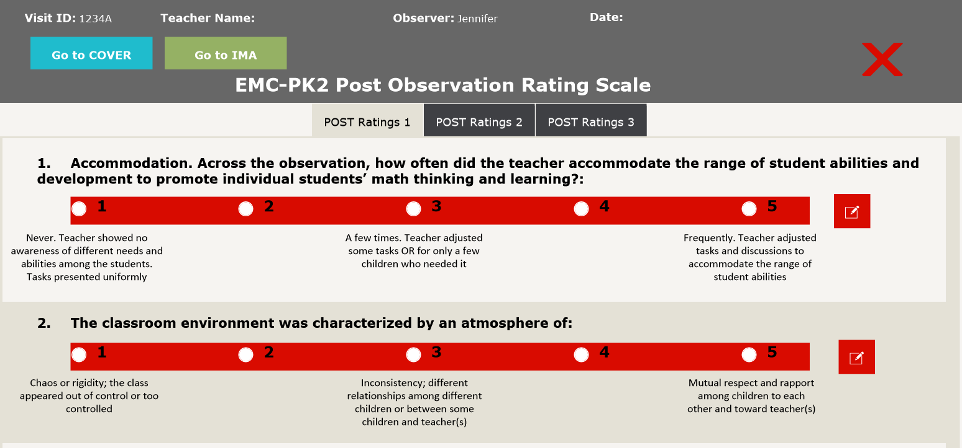
Classroom summary ratings are items about the entire observation along a 1-5 scale. The scale is tied to specific anchors that describe the rating. If the observed practice includes even elements of two anchors, the observer should pick the rating that falls in between.
When rating, the observer should start with the anchor behaviors for a score of 1, then see if there is evidence to gain points. Do not start with the anchors for 5 and take away points. Be sure to consider what happened on average across the entire observation.
Post #7 requires just a Yes/No rating.
The Classroom Summary ratings should be completed for the lead teacher only, where relevant. Do not average across all the adults in the room.
Make sure to leave notes in the provided space to explain your thinking for each rating. This can be just a couple short sentences at least, but feel free to include as much evidence as is relevant to your decision.

1. Accommodation. Across the observation, how often did the teacher accommodate the range of student abilities and development to promote individual students’ math thinking and learning?
1 | 2 | 3 | 4 | 5
Never  Teacher showed no awareness of different needs and abilities among the students. Tasks presented uniformly. |  | A few times  Teacher adjusted some tasks OR for only a few children who needed it. |  | Frequently  Teacher adjusted tasks and discussions to accommodate the range of student abilities.

Rating 1 looks at the teacher accommodating students across the lesson/observation. Adapting the task within the lesson is just one of several ways a teacher could accommodate students across the lesson. Other examples of things that could lead to a high Post 1 rating:
- The teacher creates different rotation groups based on skill
- The teacher gives high ability students more advanced math computer games to play while others work on different math activities.
- The TA supports a student with behavioral issues 1-1 to help complete a math task
- The teacher works closely on the math activity with students who are still learning English

2. The classroom environment was characterized by an atmosphere of:
1 | 2 | 3 | 4 | 5
Chaos OR rigidity  Class appeared out of control or too controlled |  | Inconsistency  Inconsistency; different relationships among different children or between some children and teacher(s) |  | Respect  Mutual respect and rapport among children to each other and toward teacher(s)

Examples of a 1 rating: students would not be able to pair and share or transition without incident. There might be fights, name-calling. The teacher might spend a lot of time on behavior disapprovals. Strong negative interactions between kids and between teacher and class.

Note: A rigid classroom likely involved intense and developmentally inappropriate types of expectations by the teacher (for example, expectations that Pre-K students sit completely still at all times or face punishment; or students are afraid to move for fear of getting yelled at). This is different than a classroom that is just dominated by teacher talk – which may be better captured under Post 4: Role Flexibility.

3. Across the observation, the tone of the teacher’s interactions with students was:
1 | 2 | 3 | 4 | 5
Negative  Teacher was rude or judgmental, or visibly unhappy; teacher may have been harsh or sarcastic with children, strongly negative interactions |  | Flat  Teacher is neutral and showed no expression, may have been involved in activities but showed little indication of affect toward the activities |  | Vibrant  Teacher was enthusiastic or excited about teaching, smiling or laughing with the children, strong positive interactions
Use the behavioral anchors to choose the item that best describes how the lead teacher’s tone is expressed through their behavior.

4. Role flexibility during math tasks was:
1 | 2 | 3 | 4 | 5
Absent  Teacher had complete authority during math tasks. Roles were rigid, decided and assigned by the teacher. Students did not have the opportunity to initiate math discussion. |  | Emergent or inconsistent  Teacher allowed for role flexibility in some math tasks but not others. Some students had the opportunity to initiate math discussion during some math tasks. |  | Fluid  Student and teacher roles frequently reversed; students initiated math tasks with close guidance as needed from the teacher. Students had the opportunity to initiate math discussion across all math tasks.
Role reversal isn’t just students standing up in front of the class. A teacher taking on a learner role solicits student perspectives, admits ignorance about student explanations, restates, summarizes, checks their own understanding, and fosters discussion. Students who take on an instructional role listen, affirm others agreeing/disagreeing, and restate others’ answers (Jensen et al., 2018).
Role reversal shouldn’t just be a proxy for student choice. For instance, Pre-K students selecting their own centers should not be interpreted as a role reversal.

5. Were students encouraged to share math ideas?
1 | 2 | 3 | 4 | 5
The teacher discouraged students from sharing math ideas. |  | The teacher encouraged students to share math ideas in about half of the IMAs. |  | The teacher consistently encouraged students to share math ideas across all IMAs.

Examples of strategies all teachers might use to integrate students into math discussion:

- Stopping other kids from interrupting
- Letting students gesture and show. Encourage this in addition to talking (both children and teacher(s) can do this).
- Interjecting or letting student speak in other language (e.g., “go ahead and use *your native language*” or “do you know that word in *other language*?”). Using their other language resources to help them share.
- Asking if they need more time, come back to them, rehearsing with them what they might want to say (sometimes this is during turn and talk where they try out first).

Question 5a is a follow-up to Question 5. If it’s obvious that the teacher is supporting Dual Language Learners share their ideas, using the above or similar strategies, mark “Yes.” If you don’t see any clear instances of supporting DLLs share ideas, mark “Couldn’t Tell.”
5a. Was the teacher focusing on using the above strategies to encourage Dual Language Learners (DLLs) to share math ideas?
Yes | Couldn’t tell

6. Did the teacher involve students in a discussion summing up or reviewing the math lesson or math objective of the day?
No sum up or review of any kind | Teacher-centered review: The teacher generated the summary of the lesson themselves. This could have involved the teacher briefly reviewing the lesson or students completing an independent exit ticket without discussion. Students did not have the opportunity to share ideas. | Student-centered review: The students generated the summary of the lesson. Students had the opportunity to share ideas while the teacher guided the discussion reviewing the lesson.

Special case: students fill out an exit ticket that requires them to describe what they learned that lesson in their own words, but there is no discussion. That would be coded “student-centered review” as long as it’s truly a student-generated reflection and not copying something the teacher has written.

7. Were there any significant events/behavior problems took place that may have affected the observation (major, unusual conditions that may have affected the normal course of events, such as the teacher called out for a medical emergency, or construction work taking place directly outside the classroom windows)?

Yes | No

It’s helpful in analysis to flag lessons or practices where unusual events might affect the data on that classroom. For instance, a fire drill which requires the class to step outside might mean there were fewer IMAs than normal that day. If you’re not sure whether it counts as a “significant event” or not, go ahead and mark it and leave a note about it.

References
Boston, M. D. (2012). Assessing the quality of mathematics instruction. Elementary School Journal, 113(1), 76-104.
California Department of Education. (2008). California preschool curriculum framework, Volume I. Retrieved from http://www.cde.ca.gov/SP/cd/re/documents/preschoollf.pdf
Farran, D.C., Meador, D. M., Keene, A., Bilbrey, C., & Vorhaus, E. (2015). Advanced narrative record manual, 2015 Edition. [Observation instrument]. Nashville, TN: Vanderbilt University, Peabody Research Institute.
Jackson, K., Henrick, E., Cobb, P., Kochmanski, N., & Nieman, H. (2016). Practical measures
to improve the quality of small-group and whole-class discussion [White Paper]. Retrieved from University of Washington:
http://www.education.uw.edu/pmr/files/2016/09/White-Paper.pdf
Jensen, B., Grajeda, S., & Haertel, E. (2018). Measuring Cultural Dimensions of Classroom Interactions. Educational Assessment, 23(4), 250–276. https://doi.org/10.1080/10627197.2018.1515010
National Governors Association Center for Best Practices, & Council of Chief State School Officers. (2010). Common Core State Standards for mathematics. Retrieved from http://www.corestandards.org/Math/
Ornstein, P. A., & Coffman, J. L. (2020). Toward an Understanding of the Development of Skilled Remembering: The Role of Teachers’ Instructional Language. Current Directions in Psychological Science, 29(5), 445–452. https://doi.org/10.1177/0963721420925543
Sarama, J. & Clements D.H. (2010). Classroom observation of early mathematics- environment and teaching(COEMET), [Observation instrument].
Stein, M. K., Grover, B., & Henningsen, M. (1996). Building student capacity for mathematical thinking and reasoning: An analysis of mathematical tasks used in reform classrooms. American Educational Research Journal, 33, 455–488.
Stein, M. K., & Lane, S. (1996). Instructional tasks and the development of student capacity to think and reason: An analysis of the relationship between teaching and learning in a reform mathematics project. Educational Research and Evaluation, 2(1), 50-80.
Yun, C., Farran, D., Lipsey, M., Vorhaus, E., Meador, D. (2010). Observer Manual for the Post Observation Rating Scale for the Tools of the Mind Curriculum (PRS – ToM). Retrieved from https://cdn.vanderbilt.edu/vu-my/wp-content/uploads/sites/412/2012/01/14084339/Post-Observation-Rating-Scale_Manual_061610_web1.pdf

